

**KOLEJ PROFESIONAL MARA BERANANG**

**DIPLOMA IN COMPUTER SCIENCE**

|  |  |  |
| --- | --- | --- |
| **COURSE NAME** | **:** | **WEBSITE APPLICATION DEVELOPMENT** |
| **COURSE CODE** | **:** | **CSC2173** |
| **ACADEMIC SESSION** | **:** | **SESSION 1 2023/2024** |
| **TYPE OF ASSESSMENT** | **:** | **PRACTICAL TEST 1** |
| **DURATION** | **:** | **1.5 HOURS** |

**CLO 2: BUILD DYNAMIC WEBSITE BASED ON WEB FRAMEWORK.**

**INSTRUCTION TO CANDIDATES:**

1. Time allowed is **1.5 HOURS.**
2. Execute all tasks.
3. Submit Django project folder (compressed/zip) and a document containing the screenshot in MS Teams.

|  |  |
| --- | --- |
| **Section / Question No.** | **Marks** |
| **Part A** | **/3.5** |
| **Part B** | **/12.5** |
| **Part C** | **/24** |
| **Total** | **/40** |

|  |  |
| --- | --- |
| **Personal Details** | |
| **Name** |  |
| **I/D Number** |  |
| **Class** | **DCS 4 [A]** |
| **Lecturer** | **PUAN NURHANNANIE** |

### Overview

Tables shown below are part of Car_Rental database.

CLIENT

|  |  |  |  |
| --- | --- | --- | --- |
| ClientId(PK) | Clienname | clientphone | gender |
| C1 | Ramesh | 0128889999 | M |
| C2 | Izzat | 0172342345 | M |
| C3 | Fatimah | 0146669999 | F |

CAR

|  |  |  |
| --- | --- | --- |
| CarPlate (PK) | Type | Capacity |
| AFQ4601 | SEDAN | 5 |
| JJK3301 | MPV | 7 |
| QRC5555 | MPV | 7 |

RENTAL_RECORD

|  |  |  |  |  |
| --- | --- | --- | --- | --- |
| ClientId (FK) | CarPlate (FK) | TotalPaid | startdate | returndate |
| C2 | JJK3301 | 500 | 2023-02-20 | 2023-02-25 |
| C3 | JJK3301 | 500 | 2023-03-18 | 2023-03-23 |
| C1 | AFQ4601 | 350 | 2023-03-18 | 2023-03-23 |

### Software requirement: Visual Studio Code

### Language : Python

### Framework : Django

**Part A: Create a Django project (Task 1-3)**

* + 1. Create a django project name ‘yourstudentid_name’ for example: BCS2107001_Ahmad.

django-admin startproject xxx

* + 1. Create an application Car

Path xxx>python manage.py startapp abc

**Part B: Create database using Visual Studio Code. (Task 3-4)**

* + 1. Add application in settings.py

‘abc’

* + 1. Create class based on the tables provided in overview above with appropriate:

1. Class name
2. Properties (data type, maximum number of character)
3. Composition/aggregationclass

class Client(models.Model):

    clientid=models.CharField(max_length=2, primary_key=True)

    clientname=models.TextField(max_length=225)

class RentalRecord(models.Model):

    clientid=models.ForeignKey('Client', on_delete=models.CASCADE)

    totalpaid=models.IntegerField(default=0)

    startdate=models.DateField()

**Part C: Apply database operation (Task 6-13)**

**python manage.py makemigrations -create class package**

**python manage.py migrate**

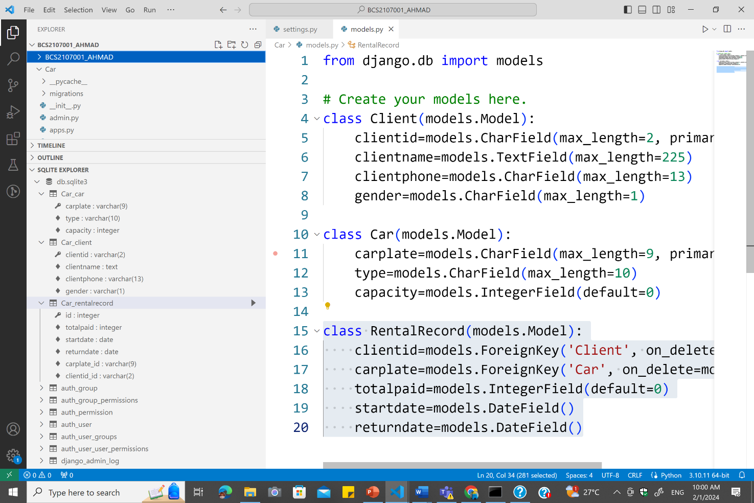

* + 1. Insert all objects into database.

Python manage.py shell

From abc.models import Client, RentalRecord

Client1=Client(‘123’, clientname=’abu’)

Client2=Client(‘124’, clientname=’ali’)

Client1.save()

Client2.save()

Fk1=Client.objects.get(clientid=’123’)

Rental1=RentalRecord(clientid=Fk1, totalpaid=400, startdate=’2024-01-02’)

Rental1.save()

* + 1. Display objects for all classes using command prompt.

Client.objects.all().values()

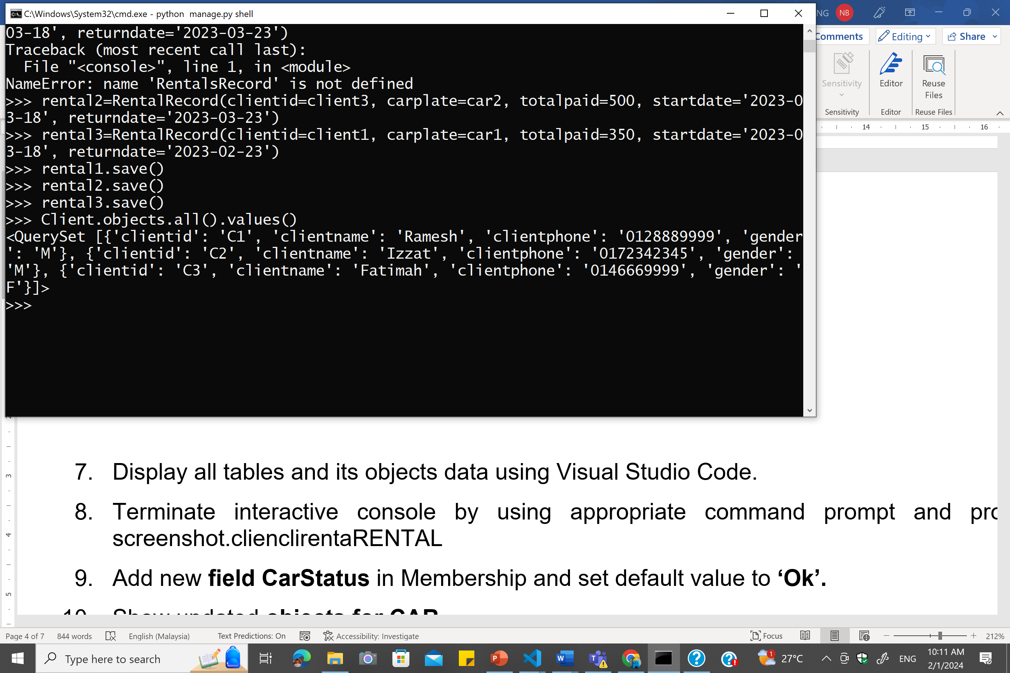

* + 1. Display all tables and its objects data using Visual Studio Code.

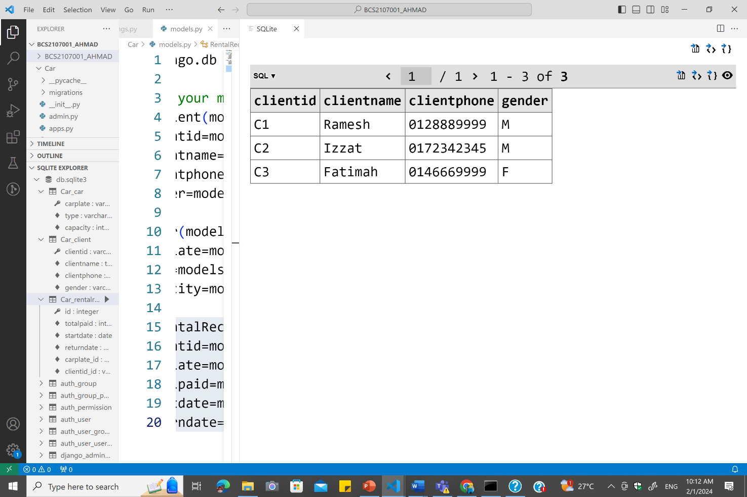



* + 1. Terminate interactive console by using appropriate command prompt and provide screenshot.

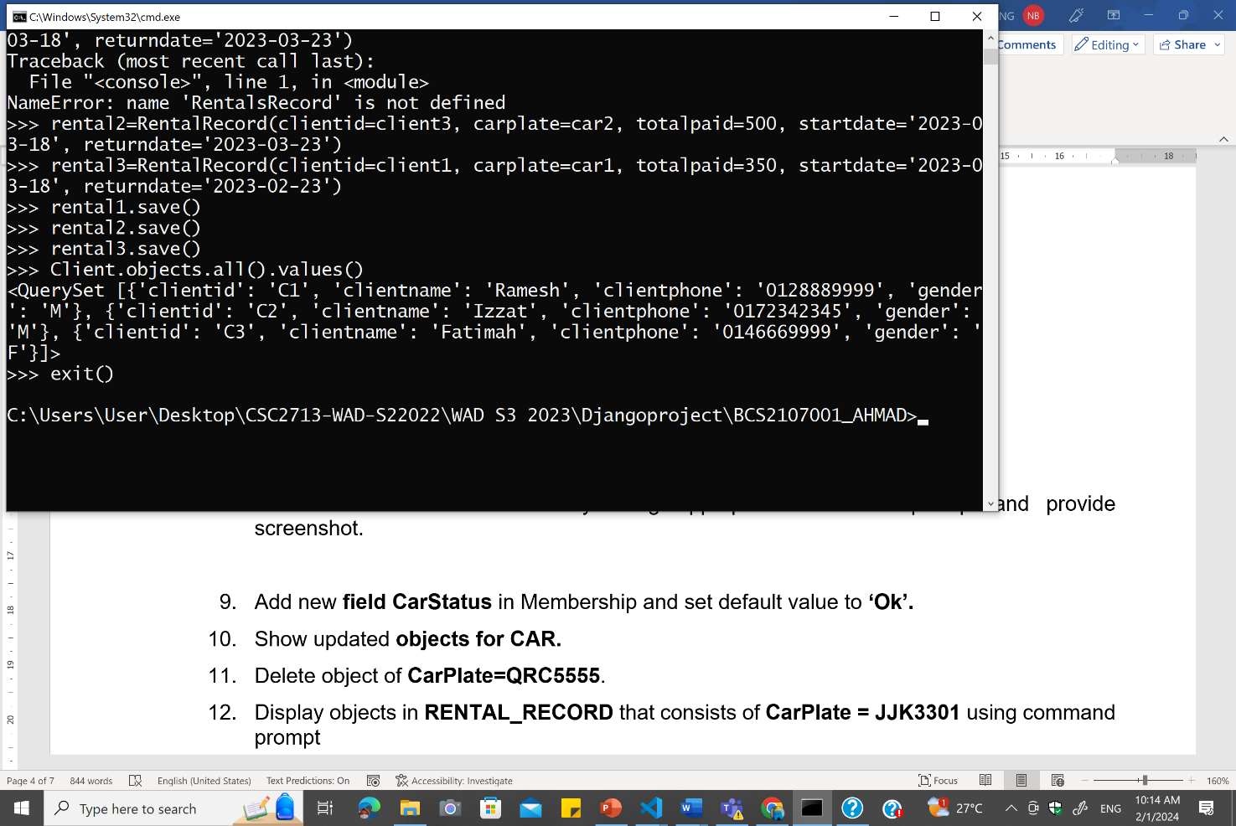



* + 1. Add new **field CarStatus** in Car and set default value to **‘Ok’.**

carstatus=models.CharField(max_length=10, default='OK')

**Makemigrations**

**Migrate**

* + 1. Show updated **objects for CAR.**
    2. Delete object of **CarPlate=QRC5555**. Car.objects.get(carplate='QCR5555').delete()
    3. Display objects in **RENTAL_RECORD** that consists of **CarPlate = JJK3301** using command prompt

RentalRecord.objects.filter(carplate='JJK3301').values()

* + 1. Display all objects in all tables after executing all tasks until task 12.

### Assessment Rubrics:

| **No.** | **Task** | **Marks** | | **Mark Obtained** |
| --- | --- | --- | --- | --- |
| **Part A** | | | | |
|  |  | * Correct projectname created. | 1 |  |
| 2 | Create a subproject name Car | * Successfully an application Car. | 1 |  |
| * Show correct command prompt used. | 0.5 |  |
| * Provide screenshot for explorer and its files in project using Visual Studio Code. | 1 |  |
| Total (Part A) : | | | | / 3.5 |
| **Part B** | | | | |
| 3 | Add application in settings.py | * Correctly add application in settings.py | 1 |  |
| * Show settings.py yang consists application name. | 0.5 |  |
| 4 | Create class based on tables provided in overview above with appropriate:   1. Class name | * Appropriate class name created. (Each class: 1m, Total: 3m) | 3 |  |
| 1. Properties (data type, maximum number of character) | * Appropriate data type and maximum length for appropriate field. (Each Class: 1m, Max: 4m) | 4 |  |
| 1. Composition/aggregation | * Correctly define key field. (Primary key and Foreign key, Total:4m) | 4 |  |
| Total (Part B) : | | | | / 12.5 |
| **Part C** | | | | |
| 5 | Insert and save data into database. | * Migration is success. (Each table created: 2m, Total: 6m) | 6 |  |
| * Provide screenshot of successful migration in command prompt | 1 |  |
| * Provide screenshot showing fields for all tables in Visual Studio Code Sqlite Explorer. | 1 |  |
| * Able to open interactive console. | 0.5 |  |
| * Successfully create data into table with at least 2 objects. (Each table: 1.5m, Total: 4.5m) | 4.5 |  |
| * Show commands in CLI for opening interactive console and creating data. | 0.5 |  |
| 6 | Display data for all tables using command prompt. | * Show tables containing at least 2 objects using command prompt. (Each table: 0.5, Total:1.5m) | 1.5 |  |
| 7 | Display all tables and its objects data using Visual Studio Code. | * Provide screenshot for all tables containing at least one object using Visual Studio Code (Each table: 0.5, Total:1.5m) | 1.5 |  |
| 8 | Terminate interactive console by using command prompt and provide screenshot. | * Provide screenshot of a successful terminating interactive console by using command prompt. | 1 |  |
| 9 | Add new **field CarStatus** in Membership and set default value to **‘Ok’** | * Provide screenshot of codings in models.py | 1 |  |
| * Provide screenshot showing updated field and objects in table using Visual Studio Code. | 1 |  |
| 10 | Show updated **objects for CAR** | * Provide screenshot of a successful command prompt to update object. | 1.5 |  |
| 11 | Delete **CarPlate=QRC5555.** | * Provide screenshot of a successful command prompt to delete object. | 1 |  |
| 12 | Display objects in **RENTAL_RECORD** that consists of **CarPlate = JJK3301** using command prompt | * Provide screenshot of a successful command prompt to display all data for the object. | 1 |  |
| 13 | Display data in all tables and its objects after executing all tasks until task 12. | * Provide correct screenshot for all tables and its objects after executing all tasks until task 12. | 1 |  |
| Total (Part C) : | | | | / 24 |
| **Total Marks Earned** | | | | / 40 |
| **Total Percentage (20%)** | | | | / 20 |